Task 1: Develop a C program that demonstrates how a Linux operating system executes a command entered by a user that 1. Accept a Linux command as input. 2. Create a child process using fork(). 3. Execute the command in the child process using an appropriate exec() system call. 4. Allow the parent process to wait for the child using wait (). 5. Display the Process ID (PID) of both parent and child processes.
- Write a C code to create a process using fork() system call.
- Read the user input as shell command.
- Use a system call exec() to execute the shell command.
- Use a wait() system call for waiting a parent process.
- Display the PIDs of parent and child processes.
OUTPUT’s:
A)
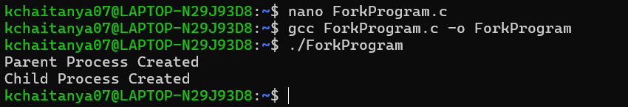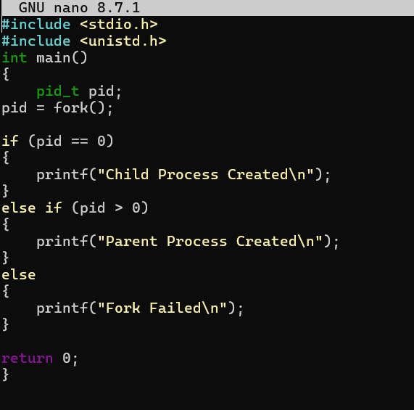

B)
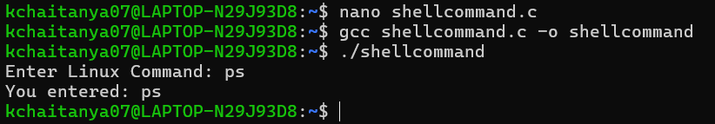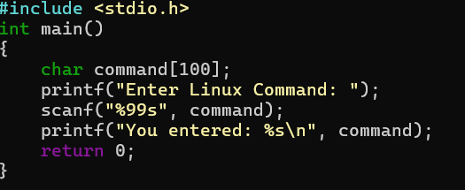

C) 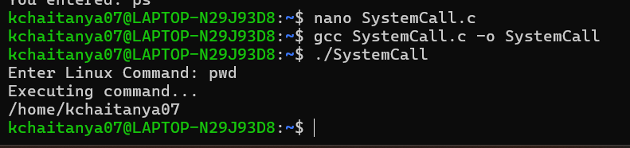
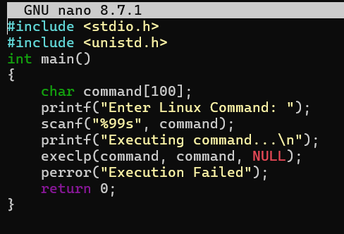

D)
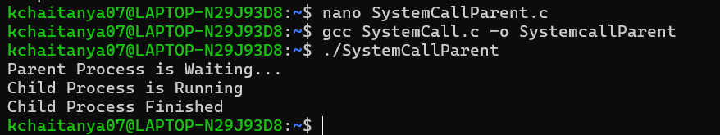
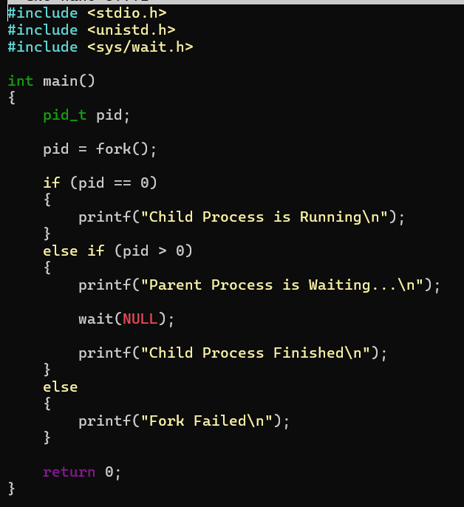

E)
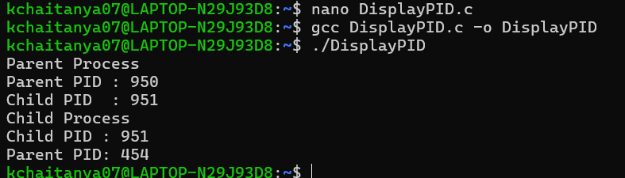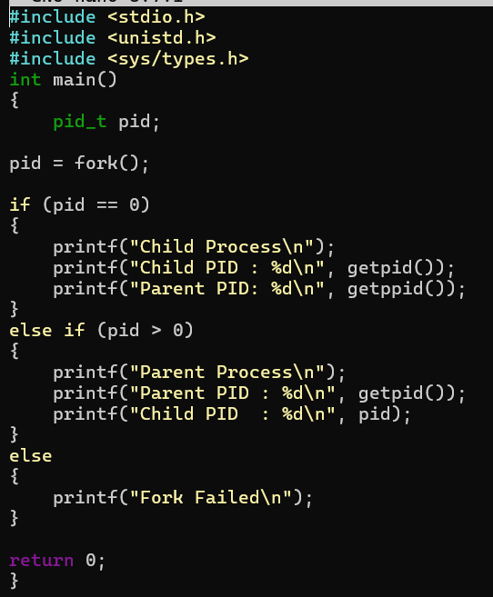

Task-2: Using Linux terminal commands (uname, lscpu, ps, top), investigate the relationship between hardware resources and operating system services. Prepare a report explaining how the OS abstracts CPU, memory, storage, and I/O devices.
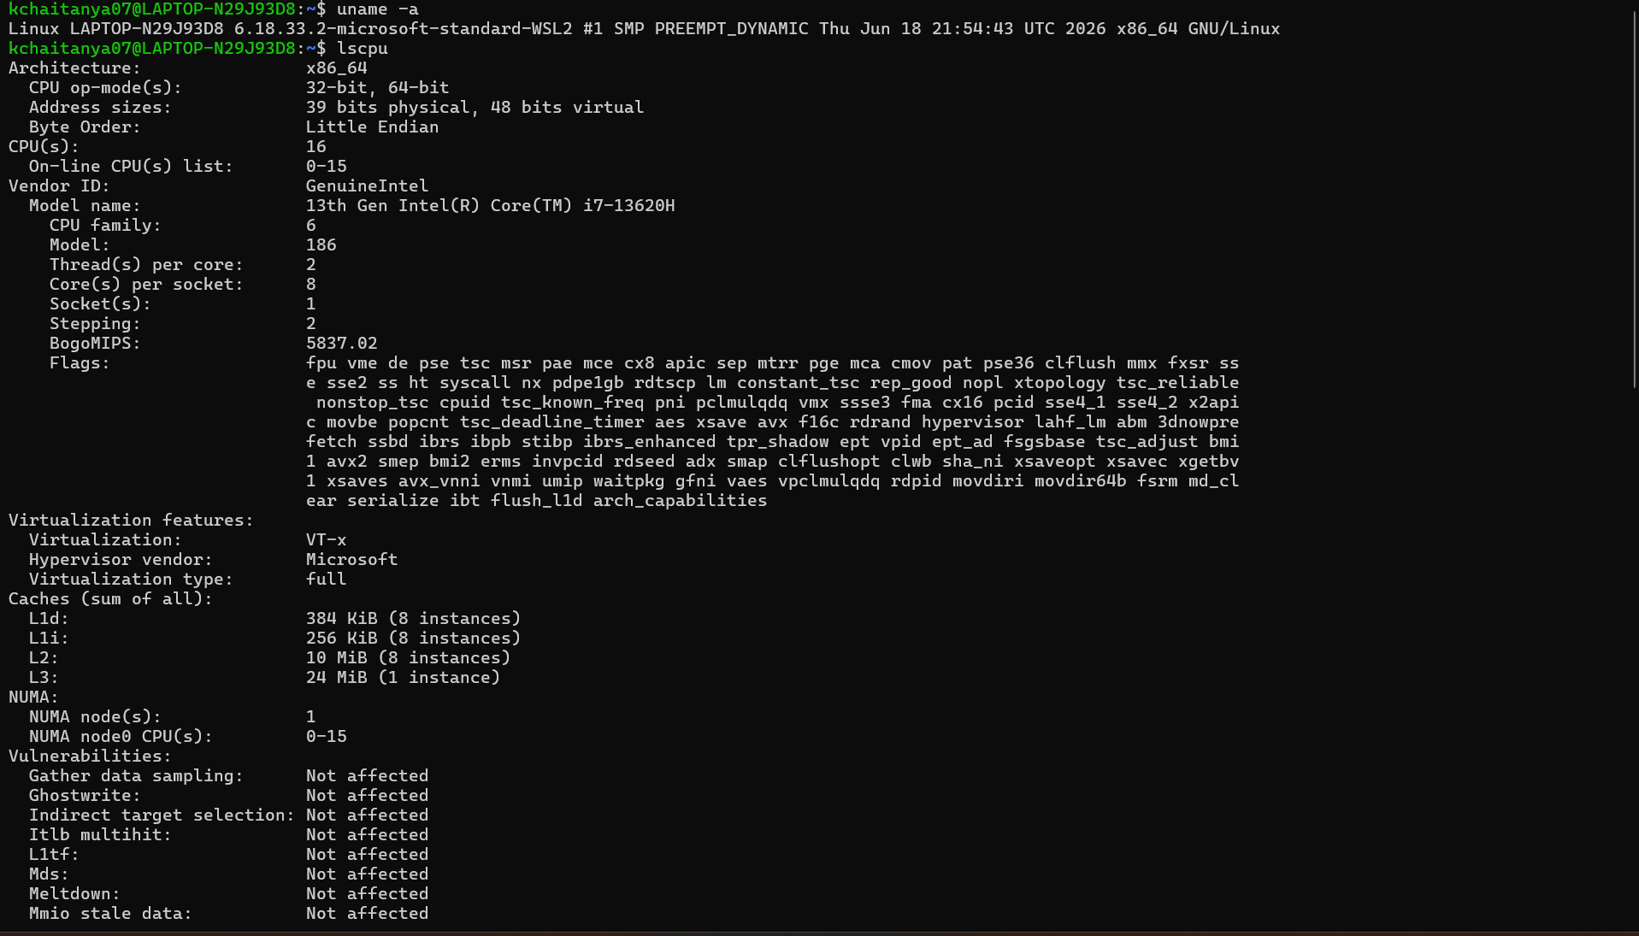
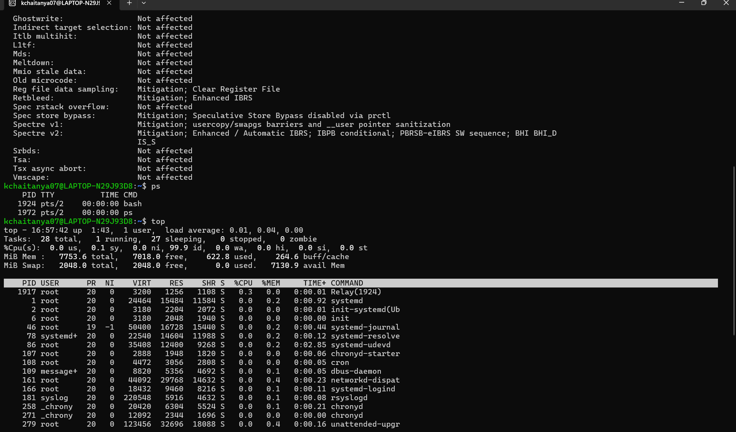
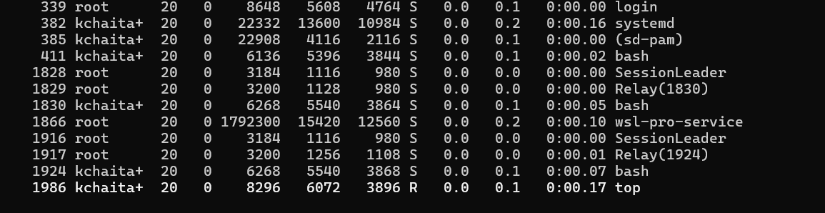

Relationship Between Hardware and Operating System Services
1. CPU Abstraction
- The operating system manages CPU execution using the scheduler.
- Each program receives CPU time through time-sharing.
- Users do not directly access the CPU.
Example:
The top command shows CPU utilization and running processes.

2. Memory Abstraction
- The operating system provides virtual memory.
- Each process gets its own memory space.
- Memory allocation and protection are handled automatically.
Example:
The top command displays RAM and swap memory usage.

3. Storage Abstraction
- The operating system manages storage through a file system.
- Files are stored on disks without requiring users to know physical disk locations.
- File operations like create, read, write, and delete are managed by the OS.

4. I/O Device Abstraction
- The operating system controls communication with devices such as keyboard, mouse, printer, and disk.
- Device drivers provide a standard interface for hardware.
- Applications use system calls instead of communicating directly with hardware.

Role of the Operating System
- Manages CPU scheduling.
- Allocates memory to processes.
- Controls storage devices.
- Handles input/output operations.
- Manages running processes.
- Provides security and resource protection.

Conclusion
The Linux operating system acts as an interface between hardware and applications. Using the commands uname, lscpu, ps, and top, we observed how the operating system manages hardware resources such as the CPU, memory, storage, and I/O devices. The OS abstracts these resources, allowing users and applications to use the computer efficiently without directly interacting with the hardware.

